**Run application via below command:**

java –jar codingTest-0.0.1-SNAPSHOT.jar

**Application home page**: <http://localhost:8080/home>

1. 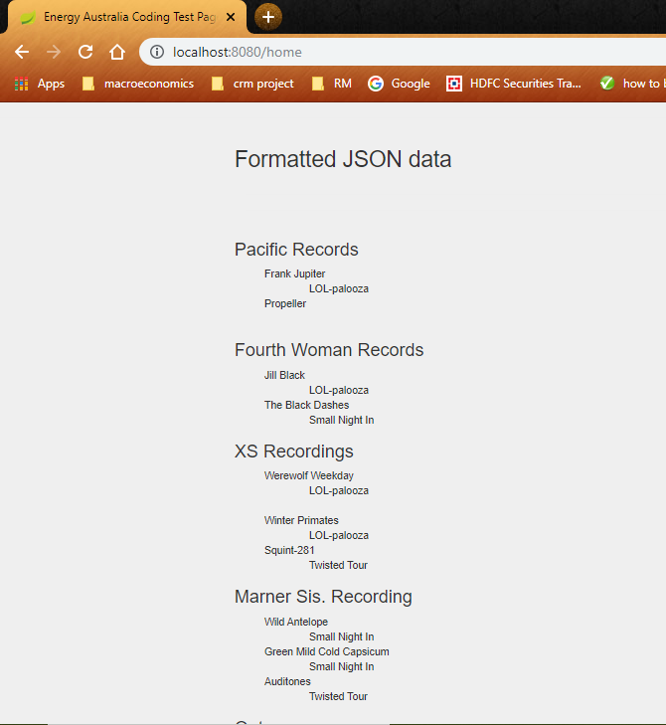
2. 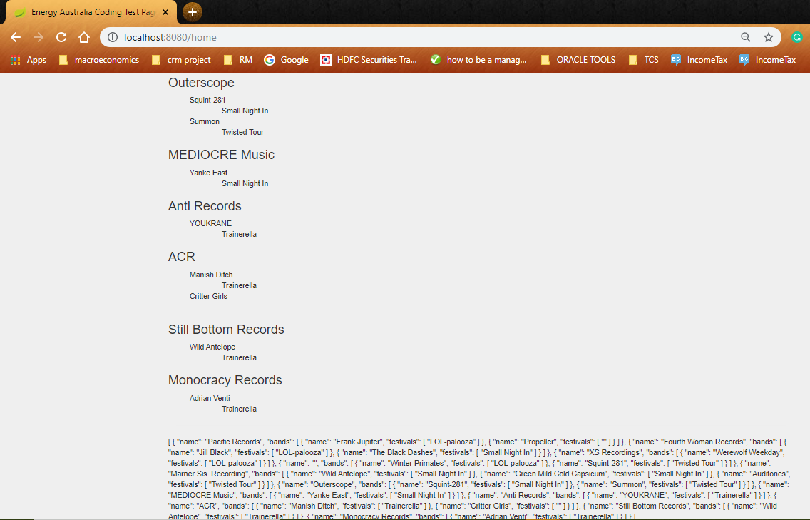

**Endpoint** : <http://localhost:8080/recordlabel/getAllRecordLabels>

